**Ex.1 *LED flasher.***

**Circuit Diagram:**

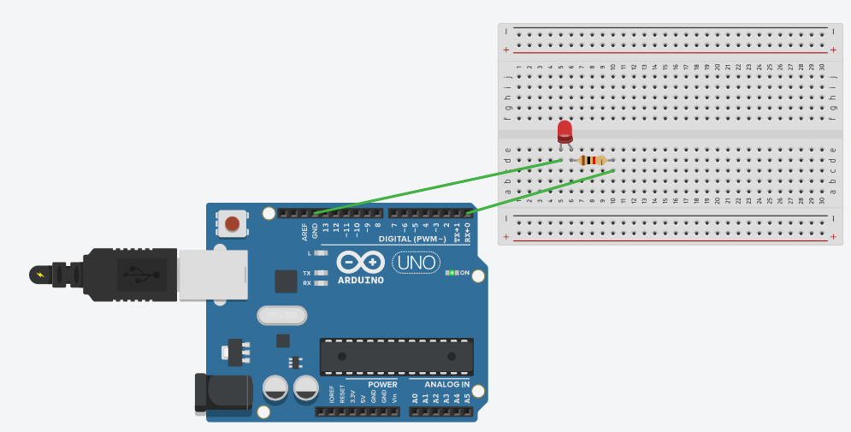

**Theory:**

**Concept Used:**

1)I used concept of how touse P-N junction diode.

2) How resistance is used in a circuit.

3) Logic code for Arduino UNO, using Loop statement.

4) How to work with Breadboard.

**Learning and Observations:**

Learning:

1)I learnt to use Arduino Board and how to code it for led flasher

2)Arduino board has Digital pins and Analog pins.

Digital pin provides Input as well as Output, but Analog pin provides input only.

3)The Arduino board has ~ sign in Digital pin side which is also known as Pulse Width Modulation(PWM).

These pins help’s in getting analog results with digital means.

4)How to work with cuircts on breadboard.

5)Since the LED can bear a limited supply of voltage so we have used resistance in series

It can not work with 5V.

6. Digital Pin provides 5V Power supply to the circuit.

**Observations:**

1)when we connect the ‘n’ terminal of the LED to other terminal except ground(GND), hence the circuit will be worng and we cannot get the desired output.

2)I connected the ‘p’ terminal of the p-n junction diodes to the Digital pins 0 in combination with the resistance, and ‘n’ terminals with the ground(GND).

3)After uploading the code on the Arduino software, the LED’s started blinking in a fixed time interval of 1000miliseconds as given in code.

**Problem and Troubleshooting:**

1)we should connect led to digital only not analog as analog can only take input.

2)The LED was not glowing due to its loose connection. By reinserting it again I was able to fix this issue.

3)I have written the code for 7 number digital pin instead of 0.

Then I rechecked the code and corrected the error.

**Precaution:**

1)Elements should be handled with care.

2)The code should be as per connections.

3)Delay should be inserted between onn and off as the code is executed so fast that the led will not flash.

4)In the IDE of Arduino the instructions should be given only in void loop section.

**Learning and Outcome:**

1)I have learnt to make circuits using breadboard, Arduino board and other equipments.

2)I have learnt how Arduino can be used in various conditions.

3)I have learnt that what are the elements of Arduino board and how they function.